TANZANIA WATER WELL PUMP STATUS MACHINE LEARNING MODEL

OVERVIEW

The water supply history in Tanzania, once buoyed by abundant resources, now faces challenges in providing consistent, clean water. This project responds by leveraging historical data on pump functionality, maintenance, demographics, and geography to predict and preempt pump failures. The aim is to create a scalable predictive tool aiding decision-makers in proactive interventions for sustainable water access.
This initiative goes beyond predictive analytics; it integrates community engagement, valuating qualitative insights. Partnerships with local stakeholders incorporate user feedback, enriching the predictive model with community perspectives. This inclusive approach seeks to build a holistic solution, uniting data-driven insights with community wisdom. This project aims not only to forecast pump statuses but also to cultivate a participatory and sustainable water infrastructure management strategy for Tanzania
The forthcoming introduction delves deeper into the intricate tapestry of Tanzania’s water landscape, unraveling the interplay of the historical challenges and the innovative strategies poised to revolutionize water infrastructure management. It navigates the convergence of data-driven foresight and community-centered wisdom, promising an insightful journey towards a trans-formative approach to sustainable water access in Tanzania
INTRODUCTION
This supervised Machine Learning centers on forecasting the conditions of the water pumps within Tanzanian wells. Despite being a developing nation in East Africa, Tanzania contends with water supply challenges exacerbated by deficiencies in its water infrastructure. The dataset utilized originates from GeoData Consultants Ltd via the Taarifa platform, capturing water point statuses and functionality. GeoData consultants Ltd , a geo-spatial consultancy firm, specializes in harnessing geographical data and spatial analysis techniques, leveraging expertise in GIS and remote sensing across diverse industries.
Tanzania’s water delivery infrastructure inadequacies contribute significantly to the limited water access dor its residents. This project utilizes geodata on operational pump and their attributes to provide critical insights. By discerning the functional, non-functional, or repair-needy status of water pumps, the project aims to address water scarcity issues prevalent in the country. This initiative aligns with efforts to alleviate water shortages and ensure consistent access to clean water for every Tanzanian citizen.

Challenges
In a developing country like Tanzania, ensuring clean and accessible piped water faces numerous challenges. Some of these challenges include:
1.`Infrastructure Deficiency`: Many areas lack the necessary infrastructure for piped water systems. Remote or rural areas might not have pipelines or water treatment facilities, making it difficult to distribute clean water to these regions.
2. Limited Access to Technology: Developing countries may face limitations in accessing advanced technology for water treatment and distribution.
3. Financial Constraints: Funding constraints often limit the government's ability to invest in water infrastructure and maintenance.
4. Population Growth: Rapid population growth strains existing water resources and infrastructure. As urbanization increases, the demand for water rises, putting pressure on already limited water sources and distribution systems.
5. Poor Maintenance: Existing water infrastructure might suffer from poor maintenance due to a. lack of resources or skilled personnel.

Proposed solutions
1.Build a predictive machine learning model that predicts whether a pump is functional , not functional or functioning but needs repair in order to reduce water shortage due to failure of pumps
2.Identify features or properties that lead to these water related problems and address them
3.Identify regions that suffer most from these challenges so we can have a map or ways on how to improve their status.
4.Investigate whether the infrastructure available is enough to meet the people's need

PROBLEM STATEMENT

The provision of clean and sustainable water access remains a critical challenge in Tanzania, with a vast network of water pumps serving communities across the country. However, the operational status of these pumps fluctuates, leading to intermittent water supply and hindering communities' access to safe drinking water. This project addresses the pressing need to develop a robust machine learning classification model capable of accurately predicting the operational status of water pumps in Tanzania.
The stakeholders invested in the success of this predictive model include;

- Tanzania Government - Ministry of Water and Sanitation:** The primary stakeholder, concerned with providing sustainable water access, maintaining water infrastructure, and ensuring water supply reliability for communities.

- Non-Governmental Organizations (NGOs):Various NGOs operating in Tanzania are invested in water resource management, community development, and improving water access. They could utilize the predictive model to streamline their interventions and allocate resources effectively.

- Water Management Authorities: Local and regional water management authorities have a vested interest in maintaining and optimizing the functionality of water pumps. They could leverage this model to enhance their maintenance strategies and water distribution systems.

- Community-Based Organizations (CBOs): Groups working directly with local communities are instrumental in ensuring sustainable water access. They might benefit from predictive insights to advocate for and implement targeted interventions within communities.

- Investors and Donor Organizations: Entities investing in water infrastructure or providing financial aid for water-related projects might be interested in the predictive model's outcomes to assess project viability and impact.

- Research Institutions: Academic institutions or research organizations could find value in understanding predictive methodologies for water infrastructure management, potentially contributing to broader research in this field.

GOALS AND OBJECTIVE
General objective;
The main objective is to build and train a machine learning model to help us predict if water pumps installed in water points are functioning, not functional or working but needs repair.
Specific objectives
Use exploratory analysis to visually understand and understand what the data is communicating and also try to understand relationship between our data columns

DATA UNDERSTANDING

Data understanding involves comprehending the dataset's structure, contents, and potential insights, examining features and their relationships to extract valuable information for analysis or modeling purposes.
-Source- The dataset originates from Taarifa, a platform collecting reports on infrastructure and services, particularly focused on water points. This data was compiled by GeoData company limited.
-Components- This dataset consists of 59400 rows and 41 columns of data. The columns are defined below:
- amount_tsh – Total statistic head. This attribute measures the water pressure available at the water source.
- date_recorded – The date the row was entered
- funder – who funded the well
- gps_height – Altitude of the well
- installer- Organization that installed the well
- longitude- GPS coordinate
- longitude- GPS coordinate
- wpt_name- Name of the water point if there is one
- num_private- number of private wells in Tanzania
- basin- Geographical water basin
- subvillage- Geographic location
- region- Geographic location
- region_code- Geographic location(coded)
- district_code- Geographic location(coded)
- lga- Geographic location(In Tanzania, LGA typically denotes the administrative region or area within the country's local governance structure.)
- ward- Geographic location
- population- Population around the well
- public_meeting- whether there was a public meeting held concerning a water point.
- recorded-by- who collected the data
- scheme_management- who operates the water point
- scheme_name- who operates the water point
- permit- if the water point is permitted
- construction_year - Year the waterpoint was constructed
- extraction_type - The kind of extraction the waterpoint uses
- extraction_type_group - The kind of extraction the waterpoint uses
- extraction_type_class - The kind of extraction the waterpoint uses
- management - How the waterpoint is managed
- management_group - How the waterpoint is managed
- payment - What the water costs
- payment_type - What the water costs
- water_quality - The quality of the water
- quality_group - The quality of the water
- quantity - The quantity of water
- quantity_group - The quantity of water
- source - The source of the water
- source_type - The source of the water
- source_class - The source of the water
- waterpoint_type - The kind of waterpoint
- waterpoint_type_group - The kind of waterpoint
- status_group- state of the pump(functional, non functional, functional but needs repair)

Dealing with outliers
Our data had a few outliers on the numerical columns. I was able to cater for the outliers in our data so as not to affect our model. Here is a plot to demonstrate it. The left plot shows how our data looks like after sorting outliers and the right plot shows the behavior of data before clipping outliers
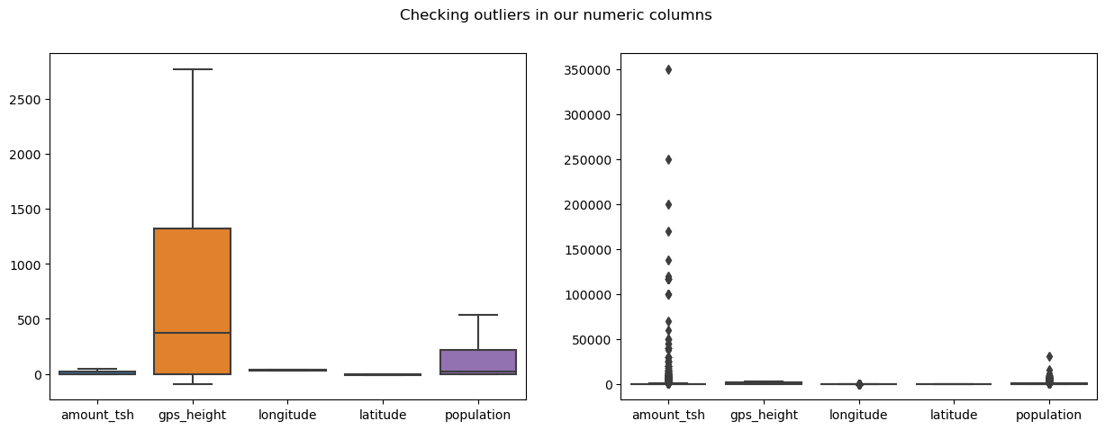

Identifying the target group
The status_group is our target column and it contains what we want to predict, the pump status. It has three target classes namely; functional, non functional and functional but needs repair. Unlike a binary classification problem this is a ternary problem meaning it has more than two target classes
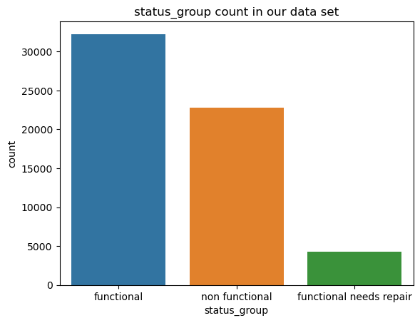

EXPLORATORY DATA ANALYSIS
Distribution of our numerical columns
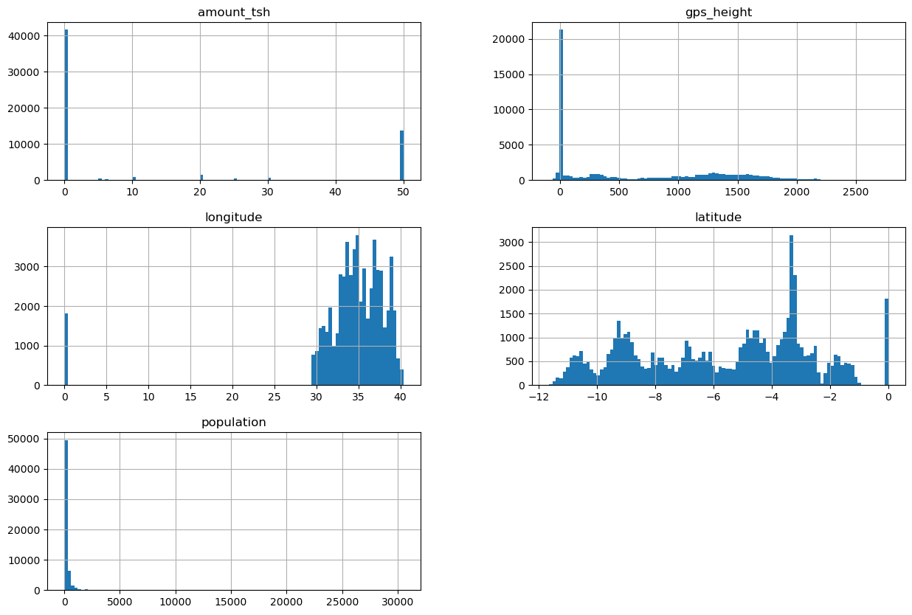
The regions under study in our data set
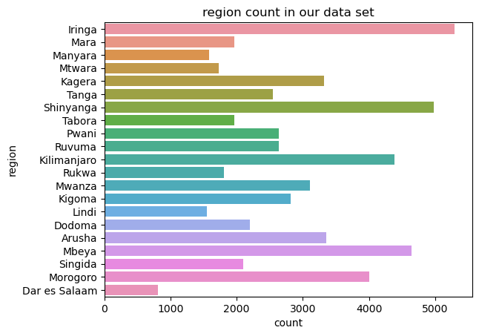

The major types of water payment methods in Tanzania
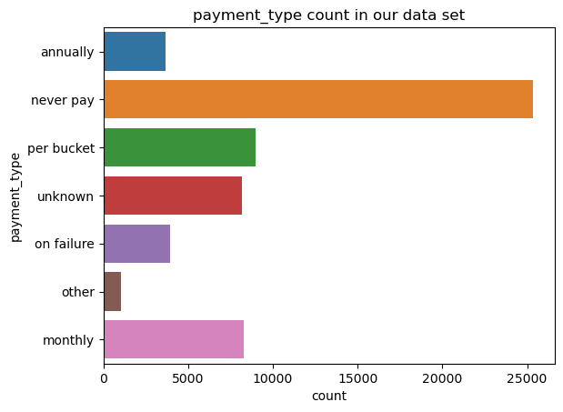
Relationship between regions and status of pumps in Tanzania

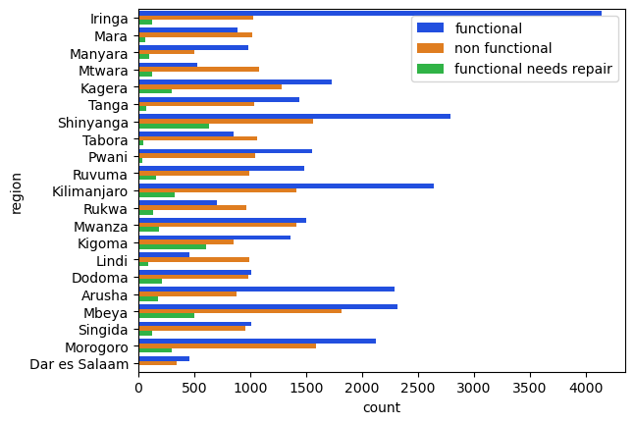

Those are just a few visuals that I selected. Visit the plots folder to examine more.
After grasping what our data is communicating , I will go into the models that I built to help us in our problem.
Modeling
These are machine learning algorithms that are trained on past data or available data in order to provide insightful suggestions on solving problems related to the data.
Metrics used to evaluate or compare these models are many but I used the following:
- Accuracy- it measures the total number of predictors a model gets right
- Recall- this metric measures what percentage of the classes we are interested in were captured by the model.
- Precision- measures how precise the predictions are. It answers the question out of all the times the model said a pump is defective, how many times did the pump in question actually defective
From the metrics above we can see that the `RandomForest` and the `tuned RandomForest` have the high accuracy score. These are the two best machine learning models in terms of accuracy score. I will foregore these two for the `GradientBooster` or the XGBoost since the boosting algorithms do well on unseen data unlike the RandomForest which does well on training data but does poorly on the validate and test data.

In general XGBoost was the best performing model with a accuracy score of 70%. This model was able to do well on all the train, validate and test sets of data meaning it would perform better if given unseen data. It also had the highest number of True positives(where it predicted a model wa functional and in it got it right).This is the end of our model training, validation and testing. Machine learning models are the best to use because of many reasons but i will mention few;
Limitations
There were a few challenges between the process and are as follows'
1. Low computational power to build the models and this affected testing and evaluating process as the process of building took so long

2. A lot of dirty work to clean in the dataset. The dataset had outliers, missing values and outliers and this consumed almost all of my time on analysis.

3. There was an issue with class imbalance in the target group and had to employ techniques like weights and synthetic to curb the problem
Conclusion
In conclusion, predicting the functionality of water pumps in Tanzania presents a pivotal opportunity to ensure sustainable access to clean water for communities. Leveraging predictive models allows proactive maintenance interventions, optimizing resource allocation, and minimizing downtime. By harnessing historical data encompassing pump functionality, geographical attributes, and maintenance records, these models enable stakeholders to anticipate potential failures, prioritize repairs, and sustain reliable water access across Tanzania. This predictive capability, coupled with community engagement and qualitative insights, paves the way for a holistic approach towards efficient water infrastructure management, fostering a more resilient and inclusive water supply system for Tanzanian communities.
Recommendations
1. Investment in Maintenance: Prioritize proactive maintenance based on model predictions. Allocate resources to address potential pump failures or those requiring repair, reducing downtime and ensuring consistent water supply.

2. Regular Data Updates: Ensure continuous data collection and updates to maintain model accuracy.

3. Community Involvement: Foster community engagement to gather qualitative insights, user feedback, and local perspectives.

4. Investment in Technology: Explore the integration of IoT sensors or remote monitoring technologies to gather real-time data on pump functionality. This technology can enhance predictive capabilities and facilitate proactive maintenance strategies.
Next step
1. Deploy our model into use to see how it will perform in the business world.

2. Improve on computational power in order to analyze data with ease

